Module 5.2 Assignment
“Forest Fire Simulation: Flowchart”
Andres Chavarria
Adrienne Becton
Brian Guadron
Walter Jacobo
Ajanae Stanback
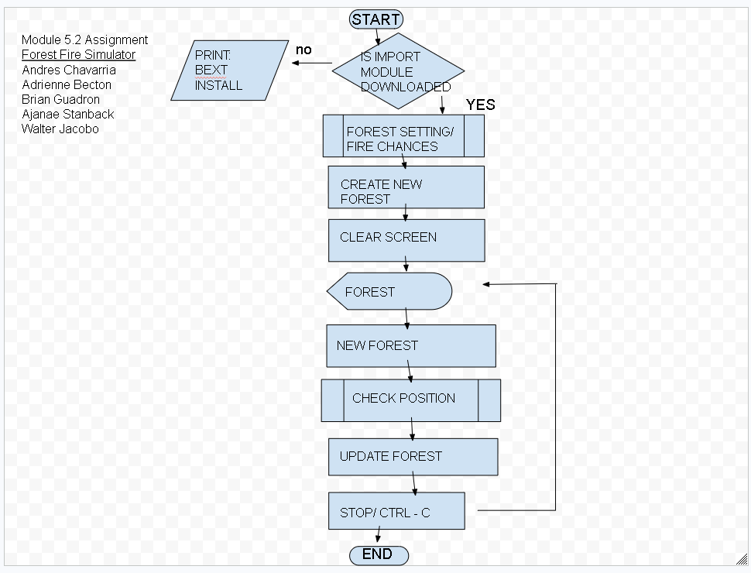

- Start program – round rectangle
- Decision module – yes or no – is the Import module downloaded - diamond
  - Yes – continue
  - No – print prerequisite/ end program
- Predefined process – forest setting/fire chances – rectangle w/ brackets
- Process – create new forest -
- Process – clear screen
- Display – forest
- Process – new forest
- Predefined process – check position
- Process – update forest
- Process - Pause - .5 sec
- Loopback – 8 display forest
- Process - Stop – ctrl -c
- End

